2022 SHEBOYGAN COUNTY 4-H CAMP

YOUTH STAFF POSITION DESCRIPTIONS & EXPECTATIONS
2022 4-H Base Camp – Upham Woods
July 10-14, 2022

QUALIFICATIONS: - At least 8th grade or older
- Willingness to be creative, energetic and compassionate
- Ability to lead and support others

POSITION DESCRIPTIONS: (You are encouraged to apply for more than one position. Positions are made available based on the strengths of the candidates and the needs of the overall camp program. )
a. RESOURCE COUNSELORS
Responsible for supervision of campers during scheduled activities. Assist cabin counselors during nonscheduled activities. Additional assignments with campers or general camp operation as needed, requested by adult camp staff or Jr. Director.
Jr. Director: Responsible for program/theme planning with camp committee. Also assist with youth staff planning and training meetings.
Campfire Director: Responsible for planning and integrating the camp theme into camp fire action. Works with and coordinates camp staff and campers to lead songs, skits and generally encourage campers. Introduces new songs, teaches cherished traditions and encouraged all staff to be involved in the campfire fun!
Recreation: Responsible for planning recreation and activities as well as facilitating reflection on personal strengths and development from these activities
Dining Room/Kitchen: Coordinate and schedule all aspects of camp dining, from set-up to clean-up. Work with adult and resources staff as available to shop, prepare, serve and clean-up snacks. Make all food related announcements.
Camp Crafts: Responsible for planning and leading craft or take-home activities and projects that will appeal to the broad variety of ages, genders and interests of campers.
Waterfront: Preferred WSI life-saving certification. Responsible for all swimming and waterfront activities.
Archery: Responsible for archery supervision and instruction along with a certified WI 4-H Adult Shooting Sports Leader.
Nature: Responsible for planning and organizing nature and/environmental lessons and activities.
Cabin Support: Responsible for providing relief and support to cabin counselors, helping cabin counselors to brainstorm strategies and troubleshoot problems.
b. CABIN COUNSELORS
Responsible for the day-to-day supervision of up to 12 campers in a cabin or cabin-side. Responsible for escorting campers to and from all scheduled activities and assisting or participating in activities led by Resource Counselors.

APPLICATION PROCESS:

- Submit the attached form no later than February 1, 2022 with at least one letter of recommendation OR Completed 4-H Reference Form from a teacher, 4-H leader and/or other community contact (cannot be a relative.)

2. Attend Camp Youth Staff Interviews February 22, 2022 at the Sheboygan County Extension Office.

Final selection of the 2022 Sheboygan 4-H Summer Camp Youth Staff will be determined by the Adult Camp Staff Selection Committee. All Sheboygan 4-H Summer Camp Youth Staff are required to attend the Camp Staff Training and Planning Sessions.

2022 4-H SUMMER CAMP
YOUTH STAFF APPLICATION

Name: ___________________________________________________ Grade: ________

Address: __________________________________________________ Phone: ___________________

City/Zip: __________________________________________________________________

E-mail Address: _____________________________________________ 4-H Club: ______________________________

Have you ever attended camp as a camper? Yes No Number of Years _____

Have you been on the camp staff before? Yes No Number of Years _____

If you have been a member of the camp staff, are you willing to help plan and lead staff training? ______

Check the position(s) you would like to apply for:

Resource Counselor - (position)____________________________________

Cabin Counselor – (age of campers) _______________________________

Why have you chosen the position (s) above? What interests you about the position (s) and what skills do you have that will help you be effective in the position (s)?

As a member of the camp staff, what will you do to contribute to the camp operation, and what do you personally hope to gain from the experience?

What 4-H and non-4-H experiences have prepared you for a youth staff position at camp?

What are some special qualifications you have that would make you a valuable member of the camp staff? (Please list specific skills and/or certifications related to being a camp counselor.)

DUE: February 1, 2022

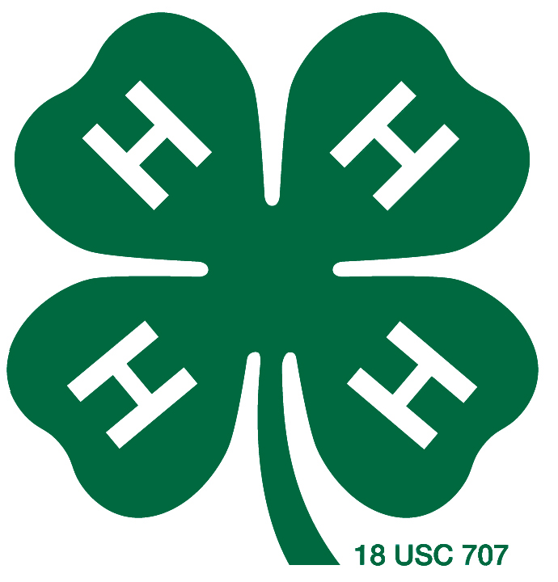
Sheboygan County 4-H Leaders Association
5 University Drive
Sheboygan, WI 53081
920.459.5903
(FAX) 920.459.5901

REFERENCE FORM(S)

Name of 4-H Member:
Camp Opportunities Applying For:
As part of the process for selecting youth for Sheboygan County 4-H Camp the selection committee is seeking recommendation and information for each candidate. Please provide us your input regarding the following areas:
Unknown Poor Fair Good Excellent
- Leadership Qualities
- Maturity
- Participation in 4-H program
- Responsibility
- Positive Attitude

Please provide additional comments in the space below:

Print Your Name: Title:
Signature: Date:
This form is to be returned to the 4-H Member Or the UWEX Office By February 1, 2022
Sheboygan County 4-H is a program of Sheboygan County UW-Extension.
THANK YOU!
An EEO/AA employer, University of Wisconsin-Madison Division of Extension provides equal opportunities in employment and programming,
including Title VI, Title IX, the Americans with Disabilities Act (ADA) and Section 504 of the Rehabilitation Act requirements.

